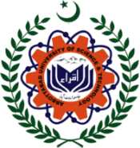 | Abbottabad University of Science & Technology  Department of _________________
 | Terminal Exam | Fall 2022 | Total Marks: 50 | Time: 2 Hours
 | BS (4 Years) | Semester: IV | Subject | ___________________
MCQ’S Answer Keys
1. |  | 2. |  | 3.
4. |  | 5. |  | 6.
7. |  | 8. |  | 9.
10. |  | 11. |  | 12.
13. |  | 14. |  | 15.
16. |  | 17. |  | 18.
19. |  | 20.

True / False Answer Keys
1. |  | 2. |  | 3.
4. |  | 5. |  | 6.
7. |  | 8. |  | 9.
10.

Fill in the Blanks Answer Keys
1. |  | 2. |  | 3.
4. |  | 5. |  | 6.
7. |  | 8. |  | 9.
10.

Short Answers
1.
2.
3.
4.
5.

Long Answers
1.
2.
3.

